How to use the 2022 Lobby Day graphic as your virtual background in Zoom

You can use the image file “2022 Lobby Day Virtual Background.jpg” as your Zoom background. Here are the step-by-step instructions for doing this from your computer, tablet or smart phone.

ON YOUR COMPUTER
- If needed, download the latest version of Zoom Client for Meetings from the Zoom download center https://zoom.us/download. With older versions of the Zoom Client, you get an error message at step 5: “Virtual backgrounds are not supported on your device.” (Note: unfortunately, on some devices it does not work even with the latest version.)
- Get the graphic file onto your computer. Save the graphic you were sent or Click on this link to open the file 2022 Lobby Day Virtual Background.jpg, right click and “save as” to your computer.
- Once you are on a Zoom meeting, click on the arrow next to icon of video camera in the bottom left portion of your screen and select “Choose Virtual Background”.

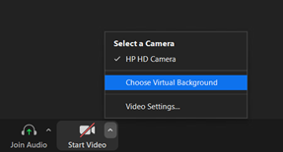

- When the options are shown, turn off “I have a green screen” if you don’t have one. If you get an error message, see #1.
- Click on the plus (+) sign to add a background and select the Lobby Day Graphic from your computer files. If you mirror your video, your logo will look backwards to you, but it will show up right-way round for everyone else.
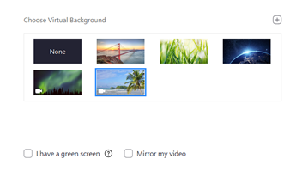

- Your background is now set and you can click out of that menu.
- To turn off use of the background, follow the directions for #5 above, and select “None”.

How to use the 2022 Lobby Day graphic as your virtual background in Zoom

ON YOUR SMART PHONE OR TABLET
- If needed, download the latest version of Zoom Client for Meetings from the Zoom download center https://zoom.us/download. With older versions of the Zoom Client, you get an error message at step 5: “Virtual backgrounds are not supported on your device.” (Note: unfortunately, on some devices it does not work even with the latest version.)
- Save the graphic file you were emailed to your photo library. You can also find it here: 2022 Lobby Day Virtual Background – Narrow.jpg
- Get on a Zoom meeting and click on the “More” menu selection at the bottom of the screen.
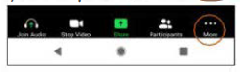

- Choose “Virtual Background”
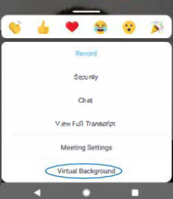

- Click on the Plus (+) sign to add a background and select the graphic you downloaded.
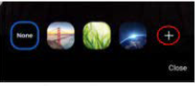

- Your background is now set and you can click out of that menu.
- To turn off use of the background, follow the directions for #5 above, and select “None”.

