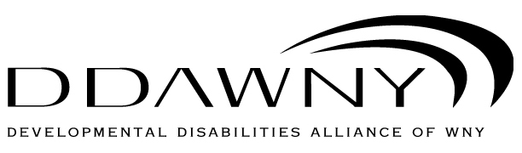

Application Checklist

Please be sure you have included the following items in your application packet:

_______ Completed Application Form
_______ Signed Code of Ethics
_______ Dues Sheet
_______ Last Annual Report (preferred) or Agency brochure

Date Submitted: __________________________________

Please submit entire packet to:
Wendy McCarthy, Association Manager
DDAWNY
835 West Main Street
Rochester, NY 14611

Or Electronic Submission to:
DDAWNY@DDAWNY.org

