|  |  |  |
| --- | --- | --- |
| OPWDD_Purple_Lockup.eps | | |
| Andrew m. cuomo  Governor | Kerry A. Delaney  Acting Commissioner | **optional third name**  Optional Third Title |

March 10, 2017

To Whom It May Concern,

This letter is to inform you that Janet Cummins is a Consultant for the Office for People With Developmental Disabilities (OPWDD) and as such is responsible for the oversight and protection of the Willowbrook class members as per the Willowbrook Permanent Injunction (72 Civ. 356, 357).

The monitoring of compliance with the terms of the Permanent Injunction include but are not limited to conducting site visits to residential and day programs as well as Nursing Home facilities across New York State to monitor and assess quality of care being received by Willowbrook class members.

Ms. Cummins shall be allowed access to all information regarding Willowbrook class members as is required for her to perform these duties.

Should there be any questions regarding this, please contact me at 518-474-6837.

Signature,

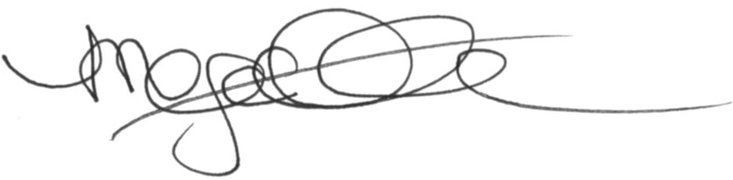

Megan O’Connor-Hebert

Deputy Commissioner

Division of Service Delivery – Regional Offices

cc: K. Delaney

H. DeSanto

W. Baer

E. Matthews

L. Lehmkuhl

B. Haroules

R. Cohn

R. Mueller