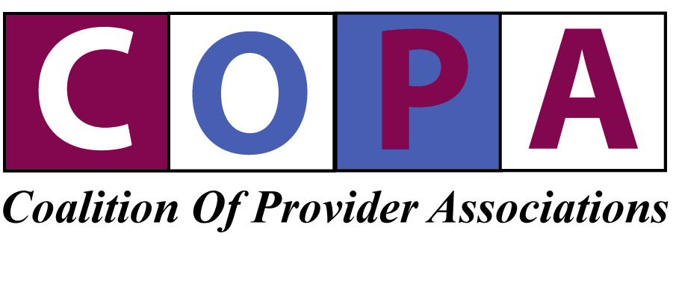
3 Cedar Street Extension, Suite 2
Cohoes, NY 12047
518.436.0467 info@copanys.org www.copanys.org

Representing More Than 250 Provider Agencies in New York State

Provider Association Meeting Minutes 3/20/17

- CMS Update. Acting Commissioner Delany is still out on maternity leave so Executive Deputy Commissioner Helene DeSanto gave an update on CMS and the communication to the Governors. Governor Cuomo received a letter from Secretary Tom Price and CMS Director Seema Verna stating that they look forward to working with the Governors and that they may give the states more time to come into compliance with the HCBS rules. Letter is attached.

- MSC Turnover. We know that, because of the uncertainty of MSC, there has been a larger than normal turnover in staff. Helene DeSanto said there is no consensus on what a letter from OPWDD to the field should say to the MSCs. There will be a small work group, including OPWDD staff and a few members of the Provider Associations, to work on a letter.

- Care Coordination Organizations (CCOs). The current anticipated transition date from MSC to CCOs is now January, 2018. The current 1115 Waiver will be amended to add individuals with I/DD into existing health home programs but with a specialized I/DD emphasis. The amendment to the 1115 Waiver will be submitted to CMS by 6/17. The amendment of the 1115 Waiver will also include implementing managed care for OPWDD services, health homes and CCOs for individuals with I/DD. PCSS will be rolled up into the CCOs as well as MSC. CCOs will be able to subcontract with provider agencies for a short transition time. A draft RFQ/A will go out soon for a 30-day comment. DOH put out Children’s Health Home Guidance, and while that is good information, there will be more specific guidance for the I/DD Health Home. It is anticipated that all the waiver services will move to the 1115 Waiver, which is something we have all wanted. It may buy more flexibility which is critical under managed care.

- 01 Waiver Amendment Update. OPWDD hopes for an April 1 implementation. CMS is still finalizing high-needs individuals funding proposal and provisions regarding mergers. Template funding will continue until a full year’s costs are first included in a cost report or individual is approved for high needs funding. Day respite limitation is proposed to expand from 8 hours to 10 hours per day subject to CMS approval.

- CRP Value Based Payments (VBP). OPWDD, with DOH and SED, designated three CRP programs as Centers of Excellence: The Center for Discovery, DDI and Upstate CP. A BIP grant from OPWDD funded identification of best practices in program and housing and the elements of VBP system. The Centers will hopefully have continued funding to work on the VBP system.

- Integrated Supportive Housing Tax Credit Program. A PowerPoint presentation is attached. The budget for 2017-18 includes $15 million for affordable housing capital support. OPWDD has already received applications for 4% credits for the 2017-18 fiscal year. A key change is that OPWDD is now included in Empire State Supportive Housing Initiative (ESSHI). ESSHI provides service and operating funding ($25K per year per person only for supporting housing, not for supervised housing) for individuals who are homeless (for OPWDD this is equivalent to the old Priority 1 category). ESSHI does not provide capital funds which must be obtained from another source. An orientation session will be held in April. OMH will be coordinating ESSHI program. If you wish to apply for the 4% credits or need more information, please call Tricia Downes, Maryellen Moeser or Alice Brooks at (518) 473-1973.

- New Willowbrook Consultant. OPWDD has retained Janet Cummings as the new OPWDD Willowbrook consultant. She will be visiting sites and she will carry a letter as authorization for her to enter all OPWDD facilities. A copy of the letter is attached.

- Direct Support Professional (DSP) Issues Update. A PowerPoint presentation is attached addressing the SS1 Work Group (“SS1” referred to the first recommendation in the report of the Transformation Panel regarding DSPs) and includes recruitment, retention, compensation, reduction of overtime and work-life balance. The Workgroup is meeting monthly and seek additional members, across disciplines including HR, to analyze recruitment, retention, compensation, overtime reduction among the focus areas.

- Safe Patient Handling Act Update. Under current statutory language, the statute applies to OPWDD programs. The Executive Branch is not interested in proposing an amendment to carve out OPWDD programs by amending the statute to refer to another section of the Mental Hygiene Law that does not include voluntary operated OPWDD programs, only developmental centers. Once the budget is passed, provider associations will push for an amendment.

- Pre-Vocational Services Regulations and ADM. The revised regulations and companion ADM will be released simultaneously in May. Below minimum wage rules will apply to both site-based and community-based pre-vocational services. The distinction between site-based and community-based will be based solely on whether the site where pre-voc services are provided is certified by OPWDD. If the site is not a certified site, it will be deemed community-based. The regulations and ADM will cover staff travel time, communication with families and volunteer activities as reimbursable time. The 2 hour limit on hub activities is limited to 2 hours on any day. Regarding the size of groups, a very limited exception will be available to have groups of up to 15 in very limited situations. Also, the regulations will allow for rounding up of time so that 10 to 14 minutes of services will be rounded up to 15 minutes.

- Respite Update. DOH has completed work on new respite fees and they are being submitted to CMS for its approval.

- Rebasing Work. DOH is proceeding with its entry of CFR data (2014-2015 CFR for NYC and 2015 CFR for the rest of the state) to prepare for rebasing. DOH reiterated that eligibility for template funding will end for those individuals for whom a full year’s costs are reported in the CFR used for 7/1/17 rates. Those full year costs will be included in the calculation of 7/1/17 rates and template funding for such individuals will end when the 7/1/17 rates become effective.

Attachments
- CMS Letter
- PowerPoint on Integrated Supportive Housing Tax Credit Program
- Willowbrook Consultant Authorization Letter
- SS1 Work Group PowerPoint

